**Market Segmentation**

**1. Overview**

**Objective:**

The objective of this case is to develop customer segmentation to provide recommendations such as saving plans, loans, wealth management, etc. to target customer groups.

**Data Description:**

The sample dataset summarizes the usage behavior of approximately 9000 active credit card holders over the last 6 months. The file is at a customer level with 18 behavioral variables.

**Data:** [Credit Card Dataset for Clustering (kaggle.com)](https://www.kaggle.com/datasets/arjunbhasin2013/ccdata)

Use the following link to download the dataset:

**Attribute Information:**

* **CUSTID:** Identification of Credit Card holder (Categorical)
* **BALANCE:** Balance amount left in their account to make purchases
* **BALANCEFREQUENCY:** How frequently the Balance is updated, score between 0 and 1 (1 = frequently updated, 0 = not frequently updated)
* **PURCHASES:** Amount of purchases made from account
* **ONEOFFPURCHASES:** Maximum purchase amount done in one-go
* **INSTALLMENTSPURCHASES:** Amount of purchase done in installment
* **CASHADVANCE:** Cash in advance given by the user
* **PURCHASESFREQUENCY:** How frequently the Purchases are being made, score between 0 and 1 (1 = frequently purchased, 0 = not frequently purchased)
* **ONEOFFPURCHASESFREQUENCY:** How frequently Purchases are happening in one-go (1 = frequently purchased, 0 = not frequently purchased)
* **PURCHASESINSTALLMENTSFREQUENCY:** How frequently purchases in installments are being done (1 = frequently done, 0 = not frequently done)
* **CASHADVANCEFREQUENCY:** How frequently the cash in advance being paid
* **CASHADVANCETRX:** Number of Transactions made with "Cash in Advanced"
* **PURCHASESTRX:** Numbe of purchase transactions made
* **CREDITLIMIT:** Limit of Credit Card for the user
* **PAYMENTS:** Amount of Payment done by the user
* **MINIMUM_PAYMENTS:** Minimum amount of payments made by the user
* **PRCFULLPAYMENT:** Percent of full payment paid by the user
* **TENURE:** Tenure of the credit card service for the user

**STEPS:**  
**1. Libraries used in the dataset.**

The code imports necessary libraries for data analysis and clustering, including pandas, numpy, matplotlib, seaborn, StandardScaler, PCA, and KMeans.

## 2. Exploratory Data Analysis & Data Cleaning:

* Check the shape of the dataset.
* Check information about the data.
* Check the statistical summary of the dataframe.
* Check for Null values in the dataframe.
* Fill missing values with the mean.
* Check for duplicate entries in the dataset.
* Drop unnecessary columns.

## 3. Outlier Detection:

* Find outliers in all columns.
* Remove outliers from columns with nearly 10% outlier.

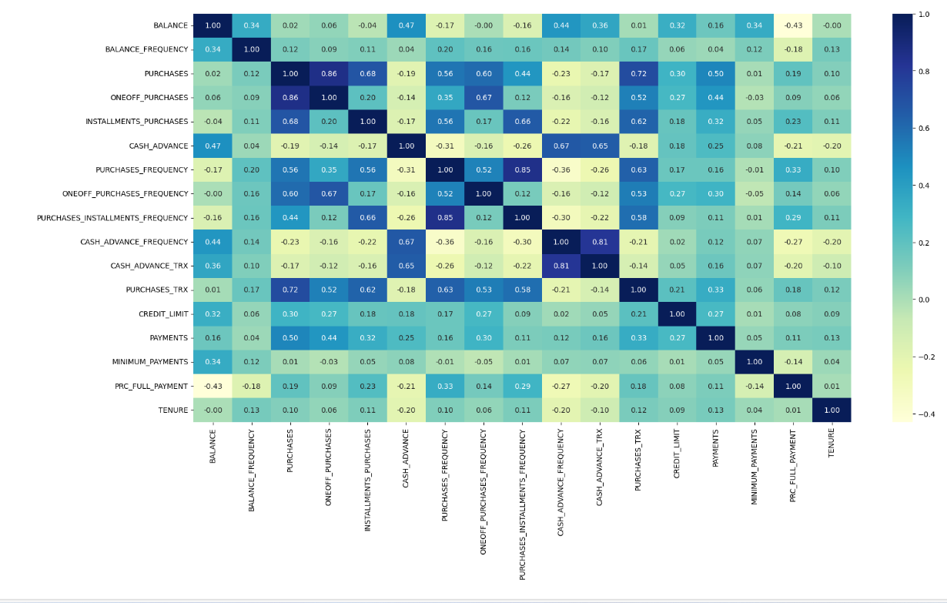

## 4. Scaling the Data:

* Scale the dataframe using StandardScaler.

## 5. Dimensionality Reduction:

* Use PCA to convert the dataframe into a 2D dataframe for visualization.

## 6. Hyperparameter Tuning:

* Find the optimal 'k' value using the Elbow Method.

## 7. Model Building:

* Apply K-Means clustering with the optimal 'k' value.
* Visualize the clustered data using a scatter plot.

## 8. Analyzing Clustering Output:

* Find cluster centers.
* Inverse transform the data to its original scale.
* Create a column as "cluster" & store the respective cluster name that they belong to.

## 9. Outcome:

* Analyze each cluster to understand customer segments.

## 10. Save The Model:

* Save the K-Means model.
* Save the clustered dataframe as a CSV file.